46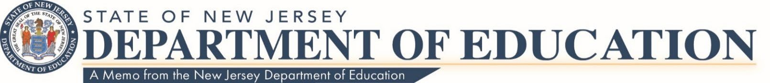

Date: August 20, 2024

To: Local Educational Agency Leads

Route To: School Business Administrators/Board Secretaries

From: Rob Amon, Director

Office of Budget & Accounting

Federal Programs: Pension and Social Security Reimbursement to State of New Jersey for Contributions Paid by the State

The New Jersey Department of Education’s (NJDOE) Office of Budget and Accounting has been notified by the Division of Pensions and Benefits that the State payment to the Teacher’s Pension and Annuity Fund for Fiscal Year 2023-2024 will be 46.70**%.**

NJDOE’s [Office of School Finance](https://www.nj.gov/education/finance/) will provide the reporting form for Federal programs under the section titled “Reimbursement of TPAF and Social Security - School Year 2023-2024 - Report Form”. The form will show the 2023-2024 **final** pension rate and Social Security rate for calendar year 2023 of **7.65%** of the first **$160,200** and **1.45%** for gross wages in excess of **$160,200.** For calendar year 2024, the rate is **7.65%** of the first **$168,600** and **1.45%** for gross wages in excess of **$168,600.**

In accordance with [N.J.S.A.18A:66-90,](https://codes.findlaw.com/nj/title-18a-education/nj-st-sect-18a-66-90.html) the above rates must be used when budgeting for Federal Programs for FY2024. LEAs will be notified by the Public Employees’ Retirement System (PERS) if a payment is due for its members.

Please note that the NJDOE will accept payments to the State by either electronic payment (ACH) or via paper checks.

**Contact information**

For any questions, please contact the Office of Budget and Accounting at [TPAF@doe.nj.gov.](mailto:TPAF@doe.nj.gov)

c: Members, State Board of Education

NJDOE Staff

Statewide Parent Advocacy Network Garden State Coalition of Schools

NJ LEE Group